LAB TASK-2

#include<stdio.h>

int main() {

int a[5];

int i;

printf("Enter the array elements: ");

for (i = 0; i < 5; i++) {

scanf("%d", &a[i]);

}

printf("Array elements: ");

for (i = 0; i < 5; i++) {

printf("%d ", a[i]);

}

return 0;

}

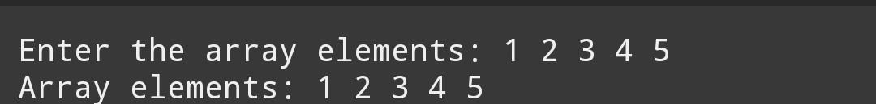

#include<stdio.h>

int main() {

int i,n;

printf("enter the value of n:");

scanf("%d",&n);

printf("Enter the array elements: ");

int a[n];

for (i = 0; i<n; i++) {

scanf("%d", &a[i]);

}

printf("\nArray elements:");

for (i = 0; i <n; i++) {

printf("%d ", a[i]);

}

printf("\nreverse elements:\n");

for(i=n-1;i>=0;i--){

printf("%d\n",a[i]);

}

return 0;

}

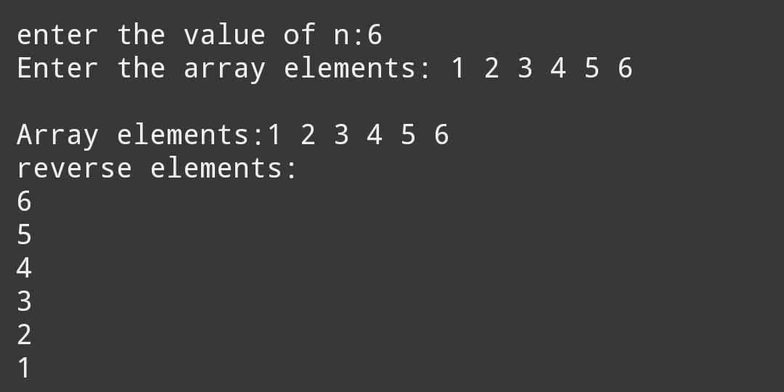

#include<stdio.h>

int main() {

int a[5];

int i, sum=0;

printf("Enter the array elements: ");

for (i = 0; i <5; i++) {

scanf("%d", &a[i]);

}

printf("\nArray elements:");

for (i = 0; i <5; i++) {

printf("%d ", a[i]);

}

printf("\nsum of elements in a array:\n");

for(i=0;i<5;i++)

{

sum=sum+a[i];

}

printf("%d",sum);

return 0;

}

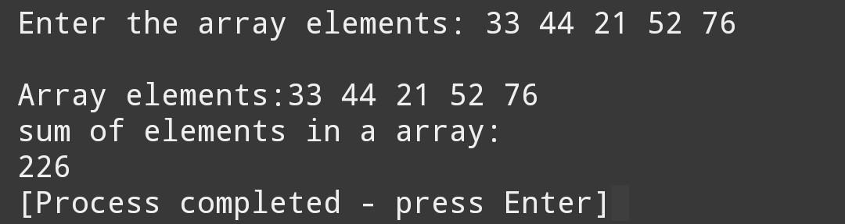

#include<stdio.h>

int main() {

int a[5], i, j; // Increase the size of the array to 6

int count = 0;

printf("enter the array elements:");

for(i = 0; i < 5; i++) {

scanf("%d", &a[i]);

}

printf("The array elements are:\n");

for(i = 0; i < 5; i++) {

printf("The array element's: %d\n", a[i]);

}

printf("Number of duplicate elements in the array: ");

for(i = 0; i < 5; i++) {

for(j = 5; j > i; j--) {

if(a[i] == a[j]) {

count++;

break; //

}

}

}

printf("%d\n", count);

if(count == 0) {

printf("No duplicates\n");

} else {

printf("Duplicates found\n");

}

return 0;

}

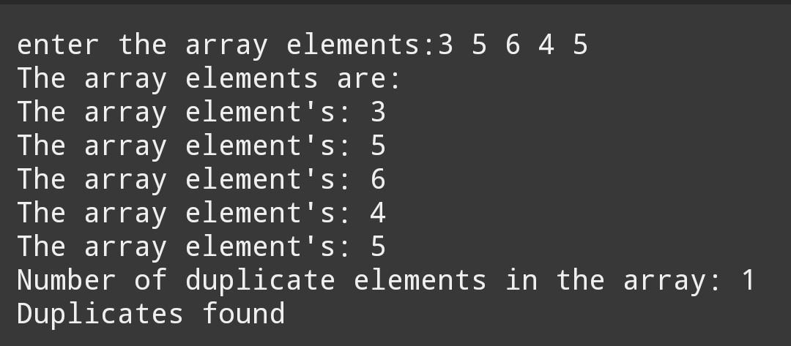

#include <stdio.h>

int main() {

int a[5];

printf("Enter 5 integers:\n");

for (int i = 0; i < 5; i++) {

scanf("%d", &a[i]);

}

int count = 0;

for (int i = 0; i < 5; i++) {

count = 0; // Reset count for each element

for (int j = 0; j < 5; j++) {

if (a[i] == a[j]) {

count++;

}

}

if (count == 1) {

printf("%d ", a[i]);

}

}

if (count == 0) {

printf("No unique elements found in the array.\n");

} else {

printf("are the unique elements in the array.\n");

}

return 0;

}

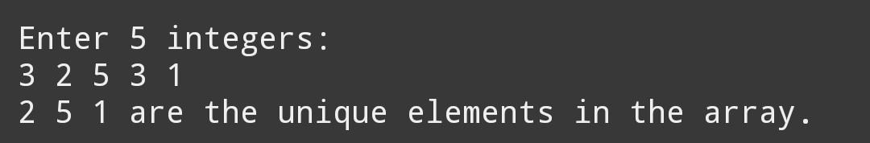

#include <stdio.h>

int main() {

int a[8];

int i;

printf("Enter 7 integers: ");

for (i = 0; i < 7; i++) {

scanf("%d", &a[i]);

}

printf("Array elements before modification: ");

for (i = 0; i < 7; i++) {

printf("%d", a[i]);

}

printf("\n");

int temp = 6;

for (i = 7; i > 4; i--) {

a[i] = a[i - 1];

}

a[4] = temp;

printf("After insertion: ");

for (i = 0; i < 8; i++) {

printf("%d", a[i]);

}

printf("\n");

return 0;

}

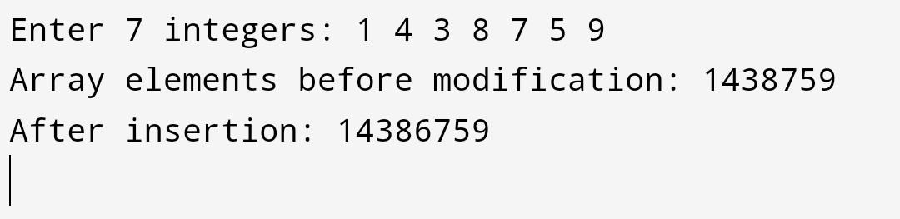

#include<stdio.h>

int main() {

int a[5];

int i, n;

printf("Enter the value of n: ");

scanf("%d", &n);

printf("Enter the array elements: ");

for (i = 0; i < 5; i++) {

scanf("%d", &a[i]);

}

printf("Array elements: ");

for (i = 0; i < 5; i++) {

printf("%d ", a[i]);

}

printf("\n after %d is deleted then:" , n);

for (i = 0; i < 5; i++) {

if (a[i] != n) {

printf("%d ", a[i]);

}

}

return 0;

}

